**PHASE 5 – PROJECT 5**

**DELPOYING ELK STACK ON DOCKER CONTAINER**

**OUTPUT SCREENSHOTS**

**CREATE EC2-INSTANCE**

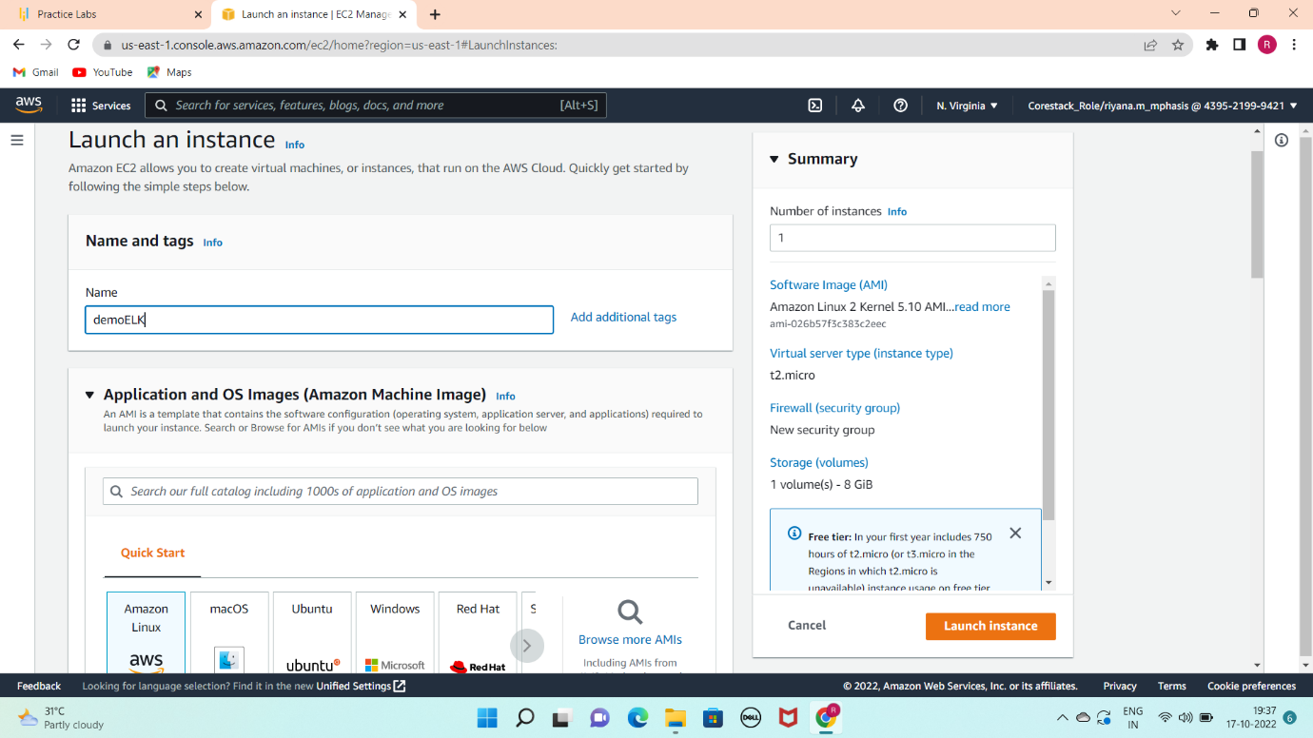

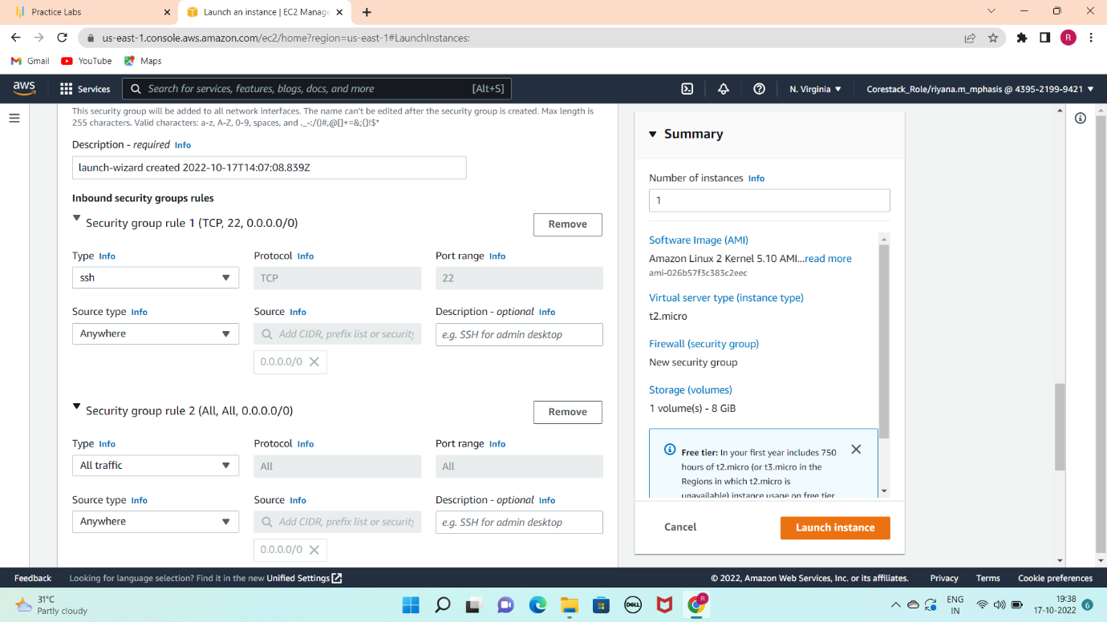

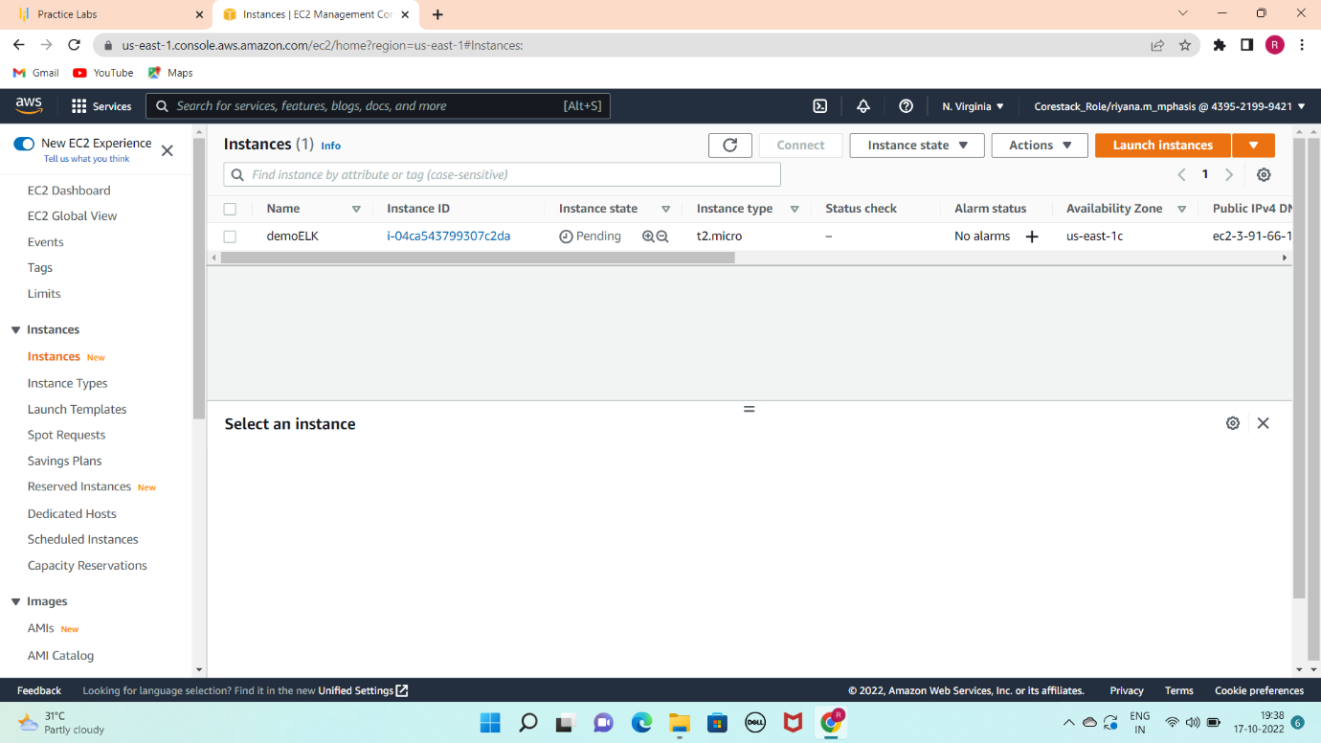

**INSTALL JAVA AND ITS DEPENDENCIES**

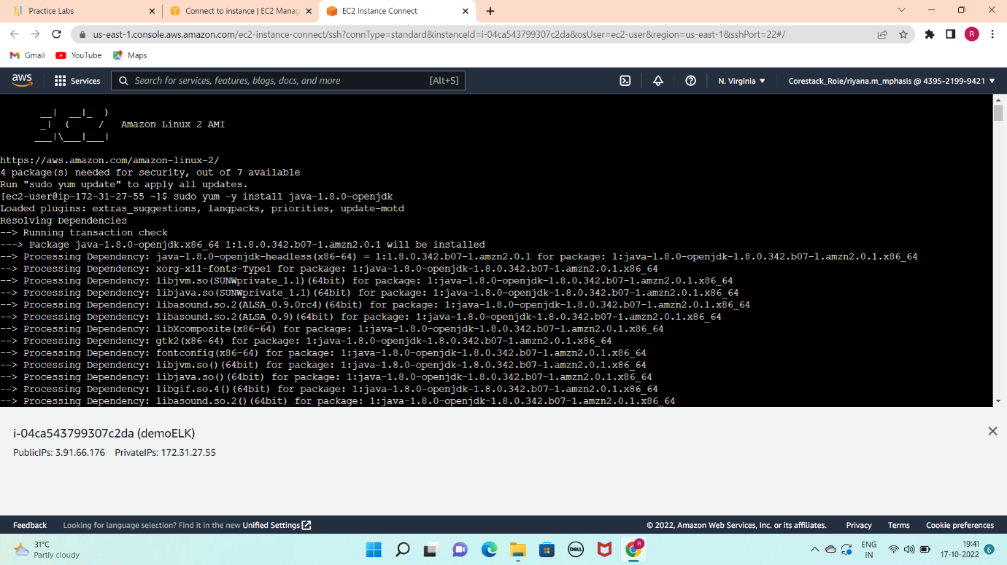

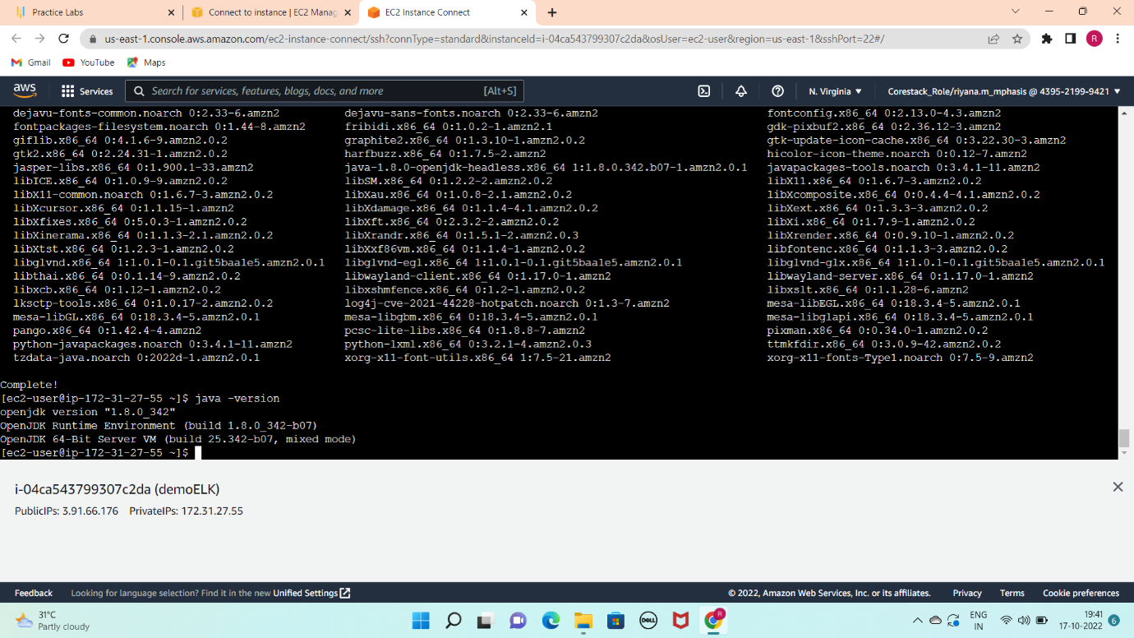

**INSTALL ELASTIC SEARCH ON AWS SERVER**

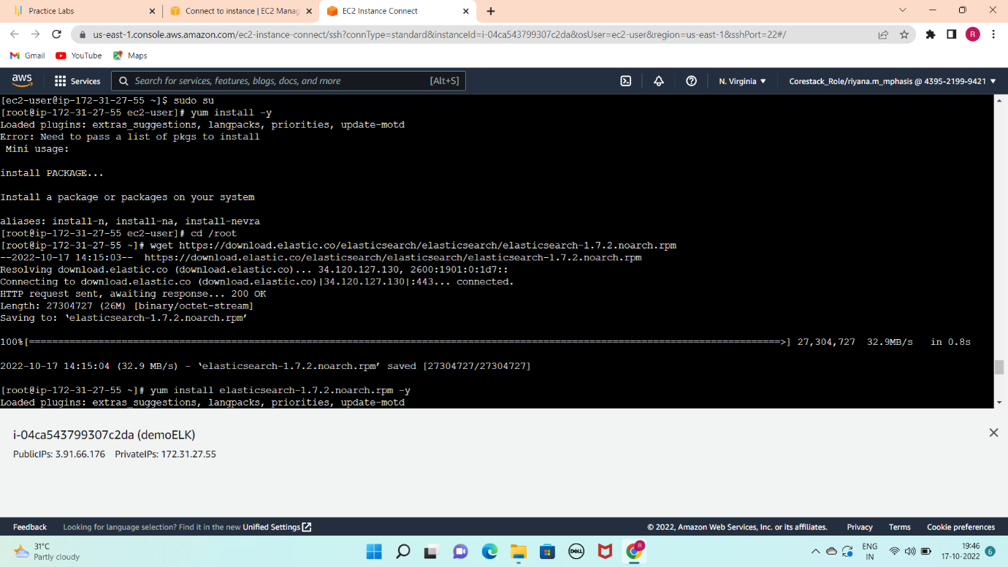

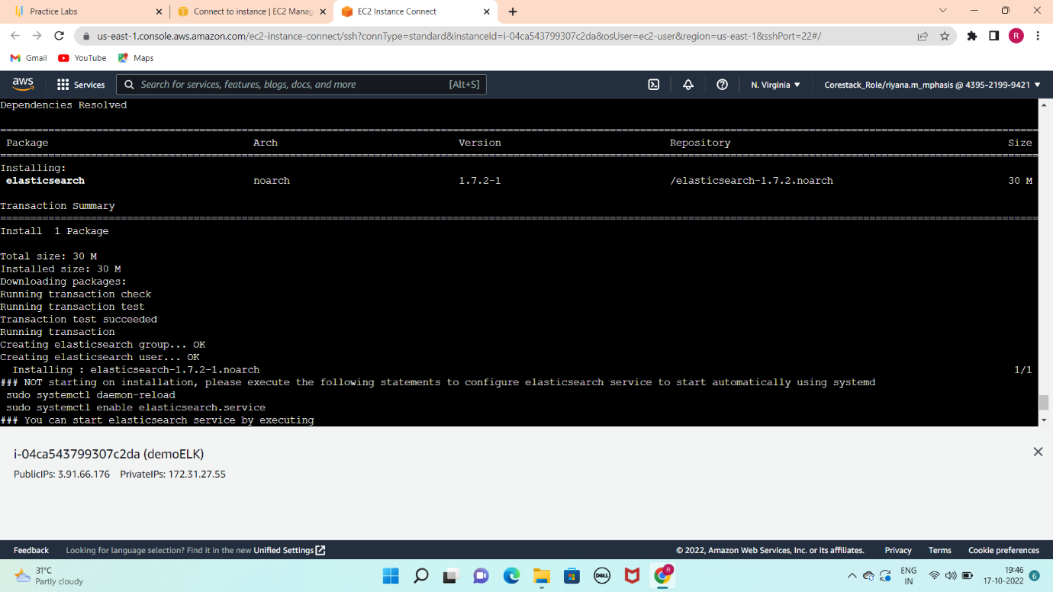

**START THE SERVER AND CONFIGURING AWS IP**

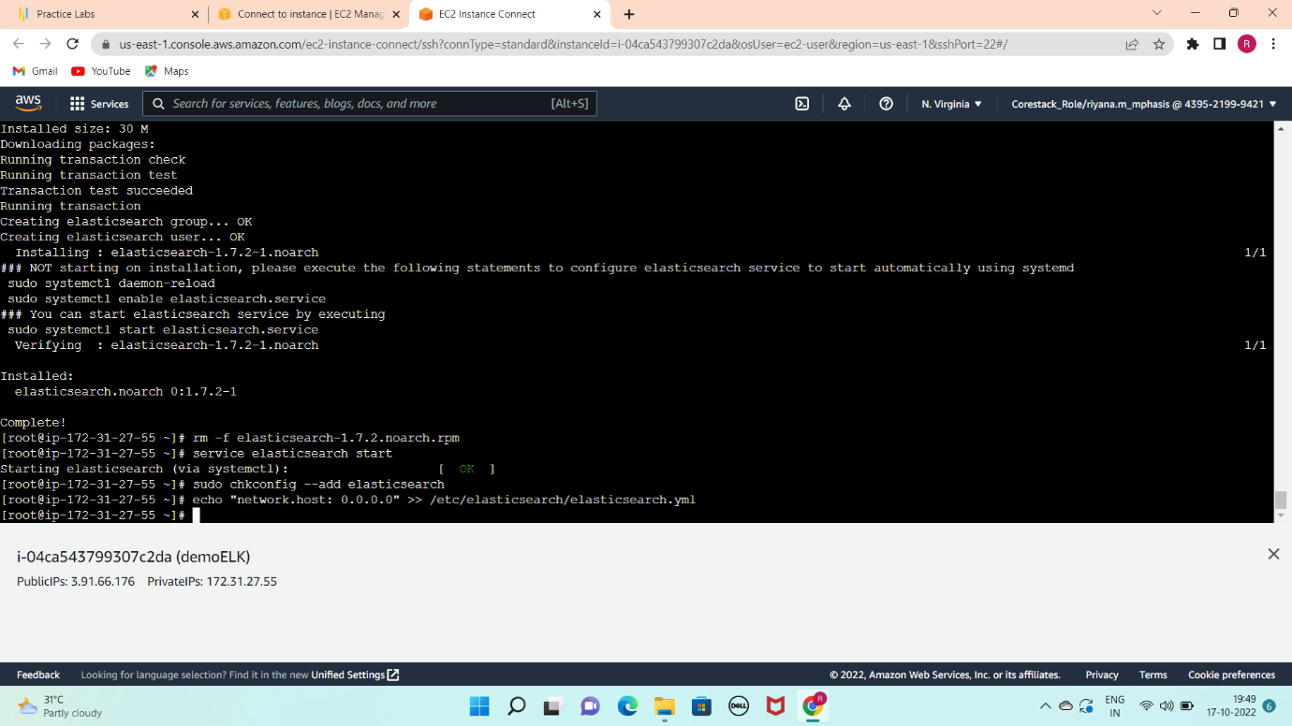

**CHECKING ELASTIC SEARCH**

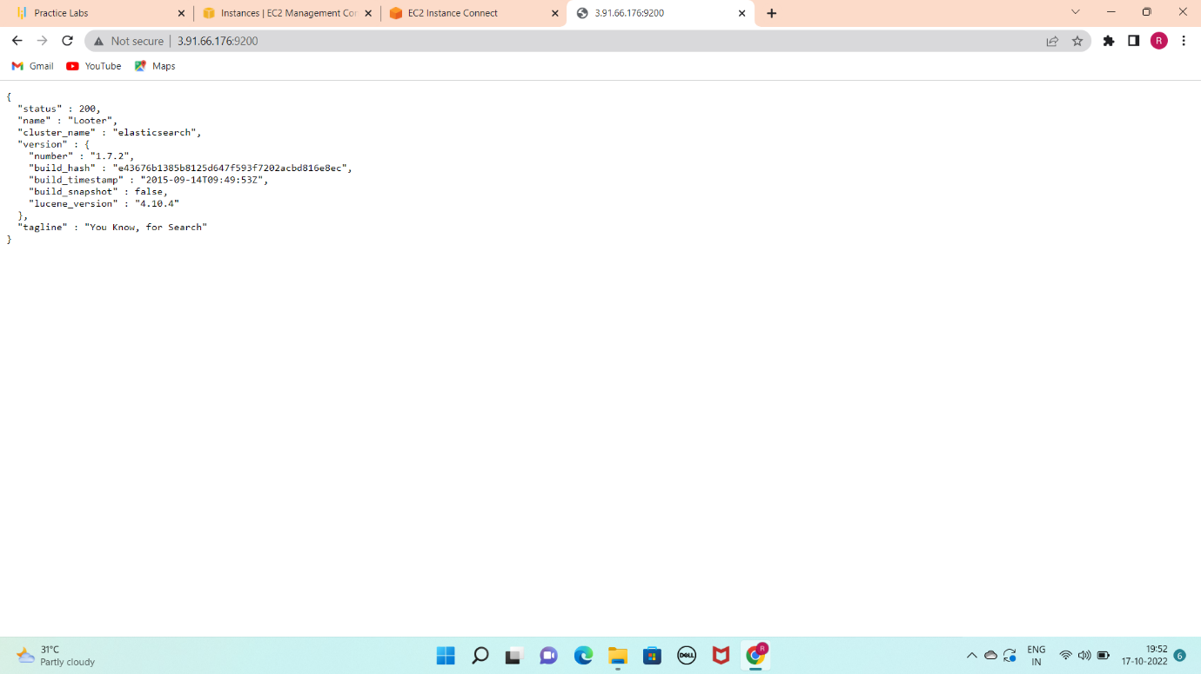

**INSTALL PLUGINS**

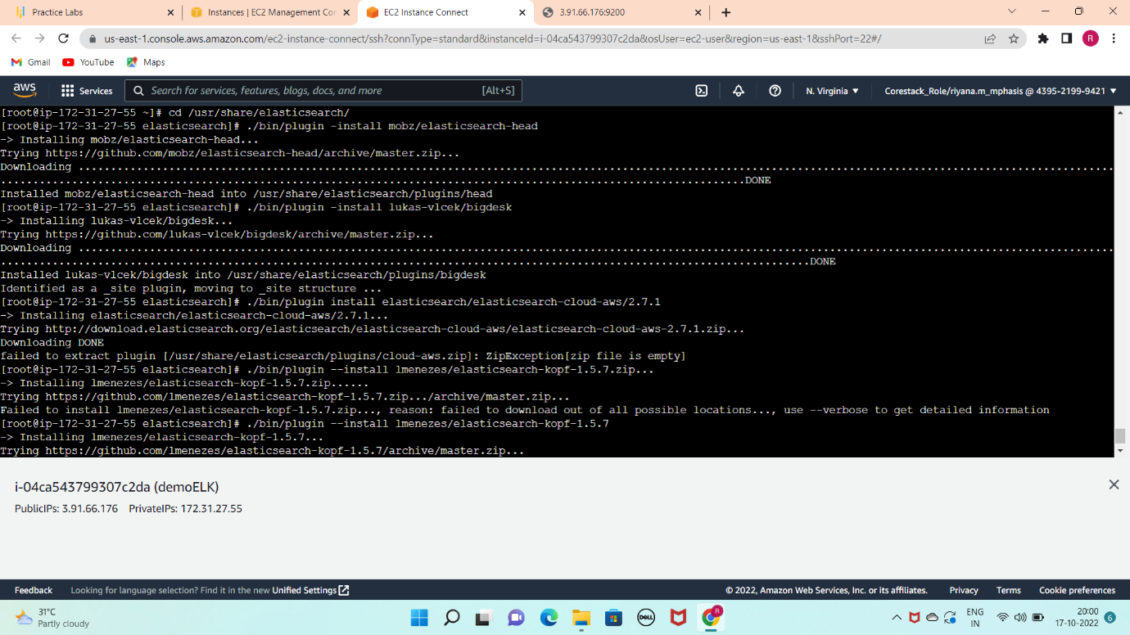

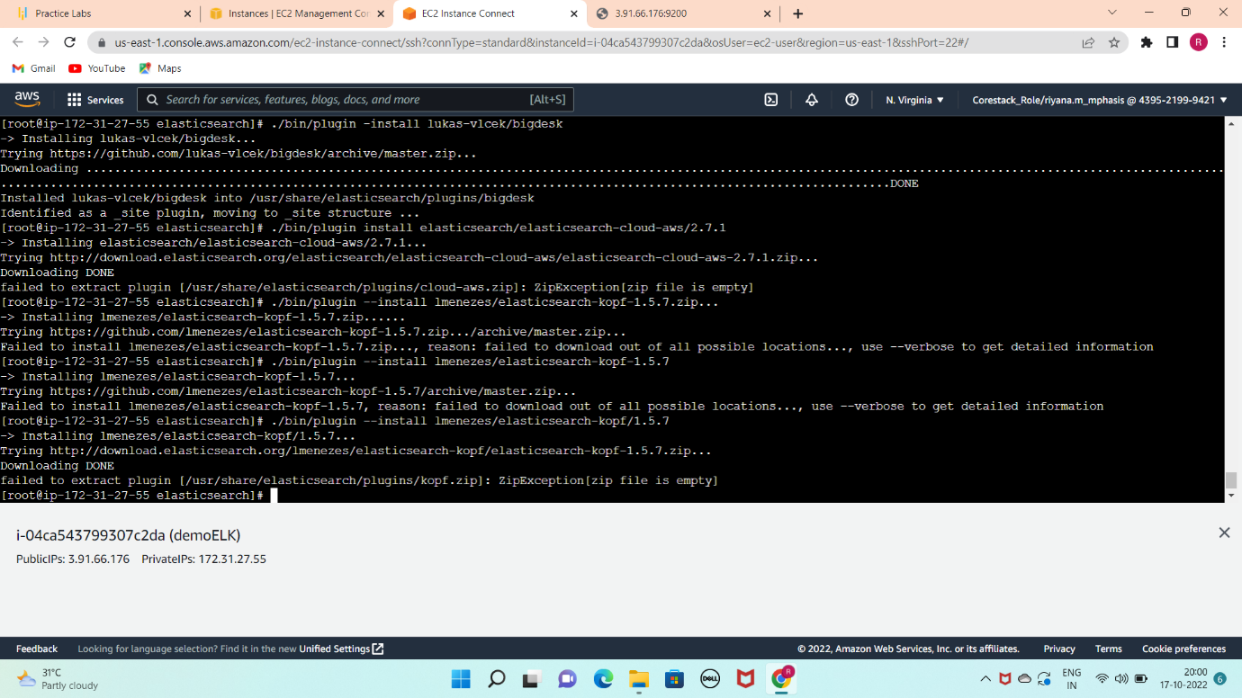

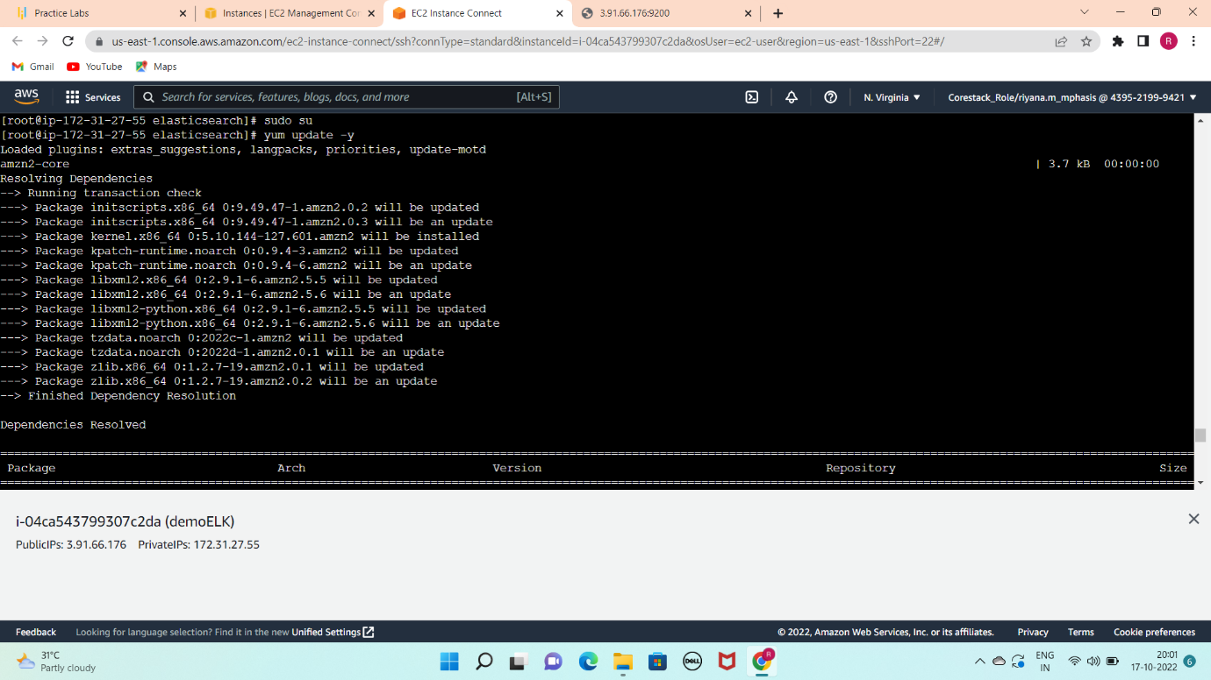

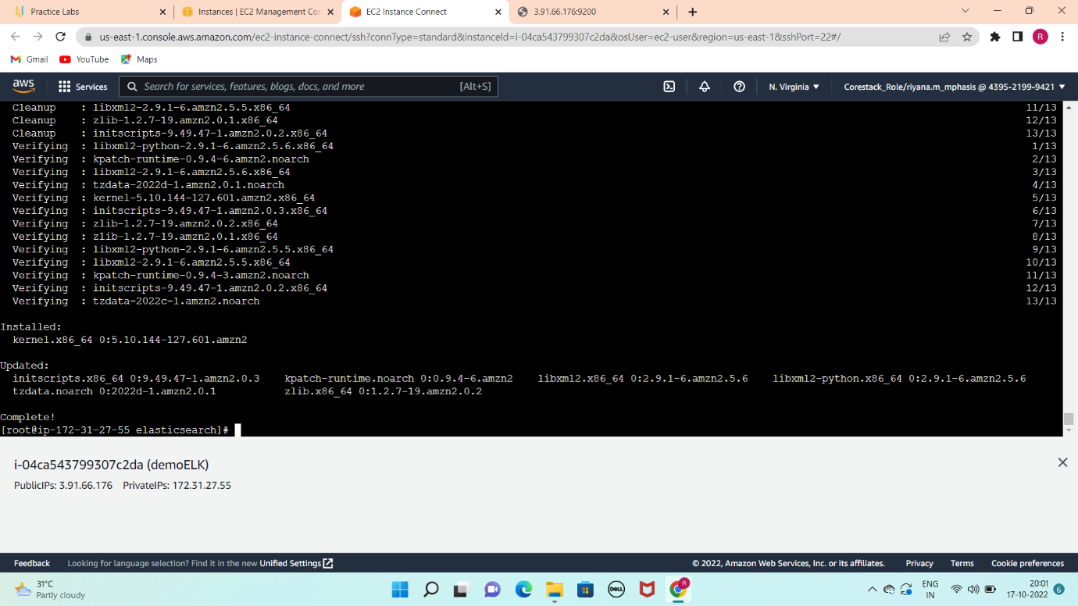

**KIBANA INSTALLATION**

